Chai Na Pol AkaraSupaset’s Livability Criteria

1. Which are your top livability criteria?
My top livability criteria are: Housing, Climate, Safety, Environment and Health Care.

2. Why do we live where we live?
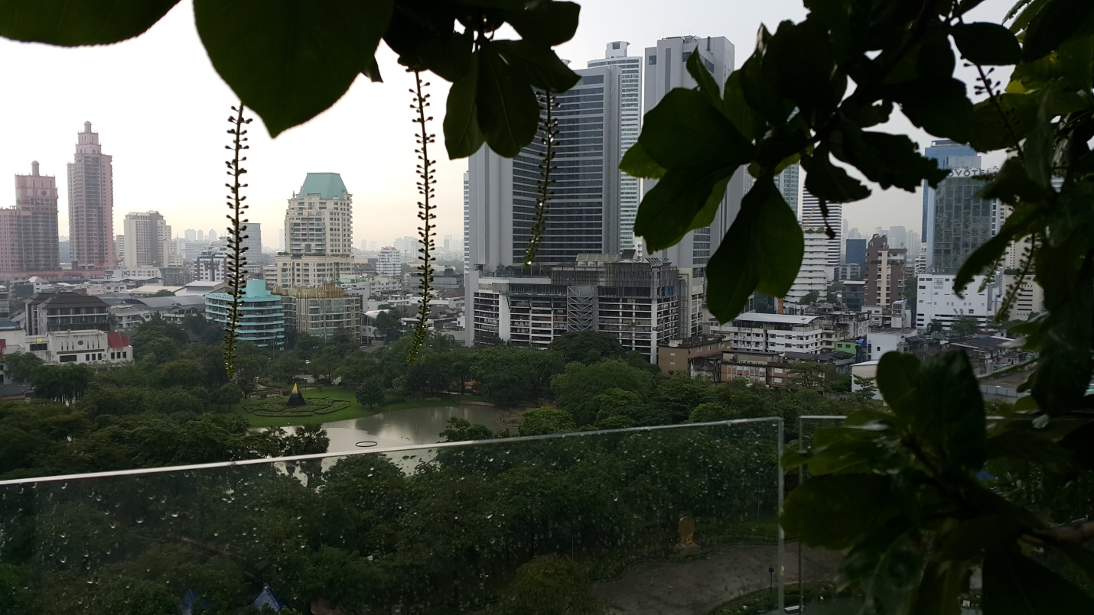A Part of Bangkok 2016
I live in Bangkok Thailand, because 1) It is my hometown 2) It is nice 3) It contains what life needs 4) It’s lifestyle is affordable 5) I feel familiar with all components.
3. To what extend does your own place of residence fulfill your ideal livability criteria?
Livability Score of My Residence
In General 70
Housing 80
Climate 50
Safety 80
Environment 70
Health Care 70

4. What would you change?
Climate and environment are what should be immediate improved. More green garden and more air flow management should be applied throughout the city.
5. Why do we move?
If it is possible, I would like to move to:

1 Samroiyod Thailand, for the reasons:
  - It has clean air.
  - It contains good environment, sea, mountain, next to convenient city Hua Hin.
  - Optimum price for such a value
  - Nice neighborhood, low crime rate
  - Beautiful contour
- Singapore, for the reasons:
  - It’s neat and clean
  - Well Systematized
  - Similar culture and living style
  - Safe
  - Affordable
- Zurich, for the reasons:
  - It’s installed in my memory. Once I have been in Switzerland, I have fallen in love with her nature, people, system and spiritual sense.
  - Medium density
  - Good environment
  - Peaceful
  - Heaven for meditation

