Module 8 - Compulsory Exercise 4

Make clear in your answer where you can find the ecosystem service and what the ecosystem offers to your living area. To support your answers you are asked to provide one or more images for every example that describe the respective services.
a. Provisioning services
b. Regulating services
c. Habitat or Supporting services
d. Cultural services

I will present an information about the ecosystem in my country (Saudi Arabia).
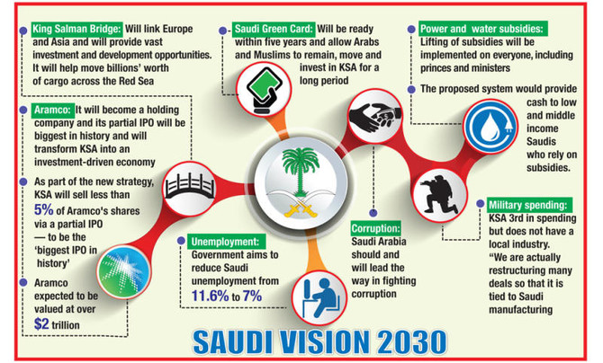
Saudi Arabia Vision is built around three themes: a vibrant society, a thriving economy and an ambitious nation. This first theme is vital to achieving the Vision and a strong foundation for economic prosperity. We believe in the importance of a vibrant society. Members of this society live in accordance with the Islamic principle of moderation, are proud of their national identity and their ancient cultural heritage, enjoy a good life in a beautiful environment, are protected by caring families and are supported by an empowering social and health care system. In the second theme, a thriving economy provides opportunities for all by building an education system aligned with market needs and creating economic opportunities for the entrepreneur, the small enterprise as well as the large corporation. Therefore, we will develop our investment tools to unlock our promising economic
sectors, diversify our economy and create job opportunities. We will also grow our economy and improve the quality of our services, by privatizing some government services, improving the business environment, attracting the finest talent and the best investments globally, and leveraging our unique strategic location in connecting three continents. Our nation is ambitious in what we want to achieve.
We will apply efficiency and responsibility at all levels. Our third theme is built on an effective, transparent, accountable, enabling and high-performing government. We will also prepare the right environment for our citizens, private sector and non-profit sector to take their responsibilities and take the initiative in facing challenges and seizing opportunities.

