**Module 4 compulsory exercise 2**

**1.  Check the temperature differences in US cities**

I did, I think San Francisco quite lower temperature city compared to other US cities.

**2. Which are the main UHI effects that you can identify in your area?**

**- the temperature of Riyadh city in summer as my place is up to 45°, with average rate 38°. However in Rural, the temperature is lower than Riyadh city which is up to 35°.**

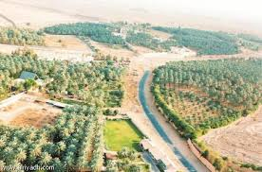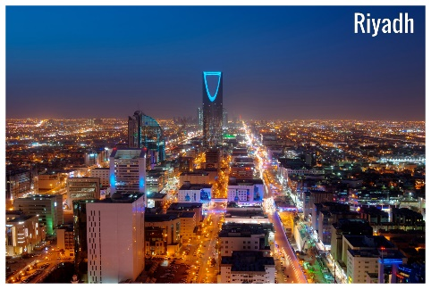

**Riyadh city Ammarih**

**The high density of population and Urban density are the main reasons to rise the temperature in Riyadh city compared to AL-ammarih rural, low density, more urban spaces, and more farms.**

**3- Which are the measures you would propose?**

If you could take part in the decision-making process of an initiative related to the UHI effect, which are the measures that you would propose in order to reduce it and provide a more livable environment to the citizens?

I can measure the surface temperature and air condition usage. In surface temperature, it can use satellite to provide wide vision of geographic coverage and thermal sensing. However, in air condition, air temperatures can be measured by using standard weather stations and other monitoring instruments (cars with sensors that record temperatures along a fixed line).

**4- Is UHI effect concerning policy making in your area?**

Do you know of policies in your community that are planned to reduce the UHI effect? Provide us with information regarding  any visible results.

ADA (Arriyadh development authority) has done some researches on UHI for Riyadh city and the rural areas. They found that the extension of urban areas with the rapid urban growth led to increase the UHI effect. Now, the ADA is working with some initiatives as expand the green area increase the green surfaces. Also, The recent initiative to design road with trees and grass might be useful in reducing UHI effects in Riyadh.

