1. Which are your top livability criteria?
In the list below, you can find (in alphabetical order) some of the livability criteria that official surveys use to determine the livability of a city. We want you to select the top-5 criteria that you think contribute the most to a city's livability. Order them with the most important at the top of your list.
The top 5 criteria may contribute to a city's livability :
- Job opportunity
- Economy
- Transportation
- Safe
- Housing

Why do we live where we live?
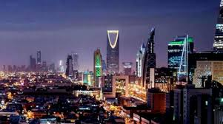
Name the place you live and provide 5 reasons why you live there. Those reasons may not be related to the official livability criteria. Order them with the most important at the top of your list. To support your statements you are asked to provide one or more images from your area of residence, that describe the reasons you selected.
I live in Riyadh city, Saudi Arabia
- Job opportunity
- Safe
- Economy
- Education
- Health
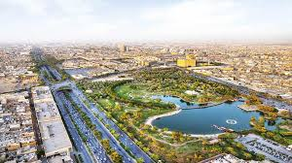

3. To what extend does your own place of residence fulfill your ideal livability criteria?
On a scale from 1-100 rate to what extend your place of residence fulfills your ideal livability criteria (i.e. the top-5 criteria you selected in Question 1).
- Safe 100
- Environment 90
- Recreational possibility 85

4. What would you change?
Imagine that you were the mayor of your place of residence. Which would be the first measure you would take to improve livability?
I believe that the design of place of residence should take the humanization as main criteria of livability.
5. Why do we move?
In this last part of the exercise, we want you to name three places that you would select to move in case you decided to change a place of residence. In addition, provide us with 5 qualities of these places that played an important role during your decision process. Order them with the most important at the top of your list.
- Diplomatic area in Riyadh city, Saudi Arabia.
- The rest of places is same.
I selected the diplomatic area for some reasons as :
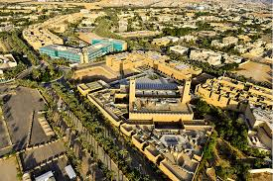
- Safe
- Housing
- Environment
- Recreational possibility
- Transportation

