Exercise 1: Making the invisible-visible
By: Arezou Shafaghat
Photo Location: Marietta, Georgia, United States of America

Exercise 1: “In the last segment, you were given some examples of how to make the invisible information visible, in the city scale. As it was mentioned, this procedure can make us understand better our cities, their functions, their dynamics, their citizens, their lifestyle and the interactions between people and built environment.”

- Identify and present two "invisible information" that can be extracted out of the visible information of this photo.”
My answers:
i) Data from car insurance system
ii)Data via Inter-locked GIS of the vehicles

- Select one of your choices from the previous question and describe how this invisible information can become knowledge and contribute to the planning of a more liveable urban space.
My answers:
- Data from car insurance system: They car insurance company captures real-time the car owners’ mobile location data of his/her driving behaviors, and especially, his/her faults. For example, any failure in good driving makes negative points and consequently lower insurance coverage for that month. As this system captures the driver’s behavior for each moment, it stores big data that can be used for other proposes. The analysis of this data would be very useful for city planners and transportation planners of the Marietta city. For example, this big data can be analyzed to indicate the distribution of vehicles in the traffic network of the Marietta city. Also, this data can indicate the potential intersections or junctions for accidents and collisions. Hence, Marietta’s urban planners can use this data in their future plans which is to resolve the traffic problems.
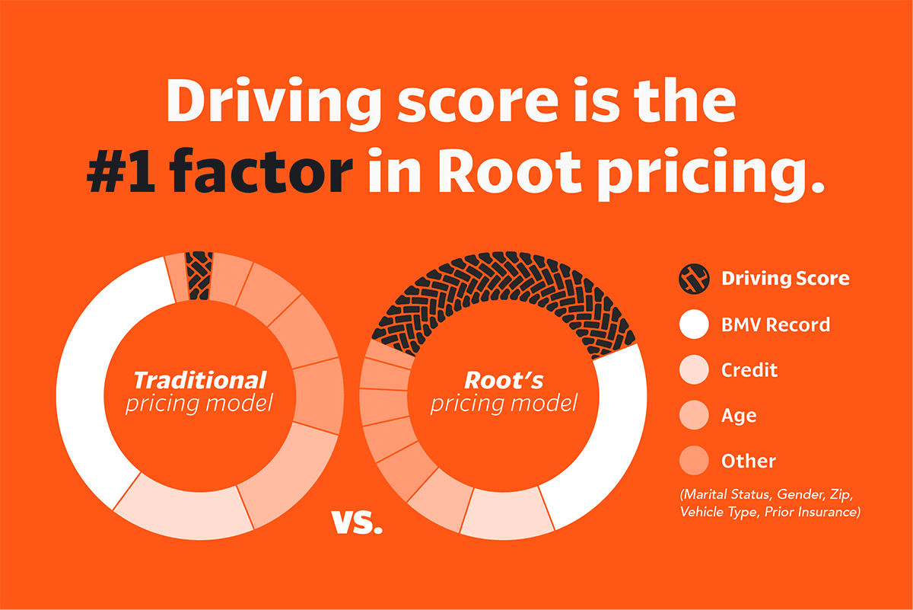
Figure: My car insurance company (i.e. Root company)
Source: https://www.google.com/imgres?imgurl=https%3A%2F%2Fwww.joinroot.com%2Fblog%2Fcontent%2Fimages%2F2019%2F03%2FHowRootActuallyPrices_DrivingScore_Graph_JH_01.png&imgrefurl=https%3A%2F%2Fwww.joinroot.com%2Fblog%2Fhow-root-prices-car-insurance%2F&docid=3Gbt4MM7B0X0-M&tbnid=SQ4ePOm4eAHHiM%3A&vet=10ahUKEwjCpviQ0r3mAhULjVkKHeCIDG4QMwhPKAIwAg..i&w=1200&h=801&bih=879&biw=1864&q=root%20car%20insurance&ved=0ahUKEwjCpviQ0r3mAhULjVkKHeCIDG4QMwhPKAIwAg&iact=mrc&uact=8

ii) Data from Inter-locked GIS device of the vehicles:
The car manufactures provide the Inter-locked GIS device for vehicles. The device captures the data of vehicle location to guide the driver for travel. This Inter-locked GIS device uses has the access to the big data of the vehicles’ location. This big data can be analyzed and used by the urban and transportation planners of the Marietta city for different purposes. For example, analysing this big data can make a the profile of urban functions of Marietta city. In particular, analysing this big data can indicate how far each vehicle travels to meet the passengers’ needs. Also, it can shows the level of accessibility to each services (such as, shopping centres, banks schools, hospitals, etc) in any neighbourhood area, any district, or whole city. Hence, this data would be used for future development of the city of Marietta; for example, site selection for each type of land uses (residential, services, transportation networks, etc.) to protect un-balanced development and density in the city of Marietta.

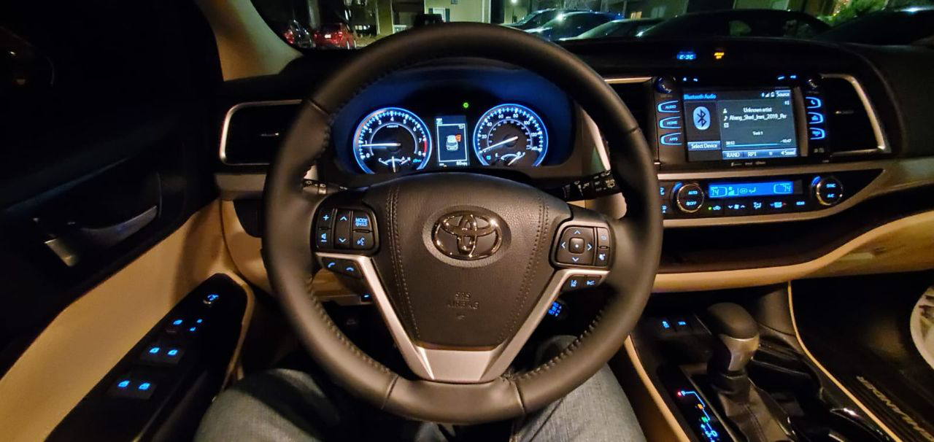
Figure: It shows the inter-locked GIS of my car
Source: Arezou Shafaghat

