Livability Criteria
- Climate
- Health Care
- Education
- Recreation Possibilties
- Safety

I live in Chandigarh. Reasons are -
- Culture
- Safety
- Services
- Education
- Recreation

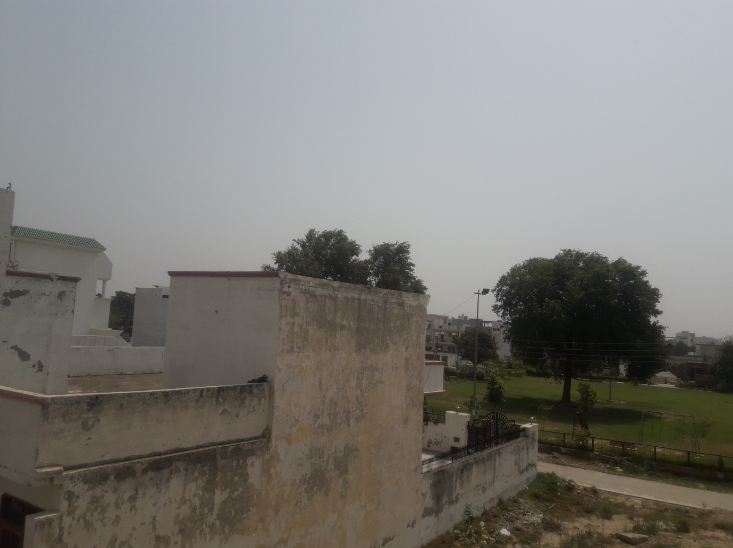

On a scale of 1 - 100 I rate my city as somewhere between 75 - 80.

If I am the mayor of my city I would like to upgrade transportation system to make it better and more transparent and to upgrade infrastructure of all sectors especially sports to make spaces more efficient and safe.

Places I would like to move-
- Las Vegas
- Copenhagen
- Thimpu

Reasons for moving-
- Happiness Index
- Safety
- Education
- Health Services
- Culture

