**LIVABLE CITIES.**

**Module 3- Compulsory excercise.**

1. Livability criteria, top five.

* Environment
* Health care
* Education
* Politics stability
* Safety

1. I live in Asuncion, Paraguay. Asuncion is the capital of Paraguay, has 524 190 inhabitants, it is the most populated area in the country.

The reason I live here is because of people hospitality, Paraguay is well-known because of that, because of relatives, friends, ect. Also we can see that in the city there are a lot of trees, greenscapes (although public spaces such as parks and plazas are not government’s best work) for a city there’s a lot of green, we also won a prize for that. (The green capital of latin America)

My borough is the best, surrounded by green spaces, rock streets, a tall area (topographically), is close to everything (entertainment, health, education, ect.) It’s called ‘’Los Laureles’’

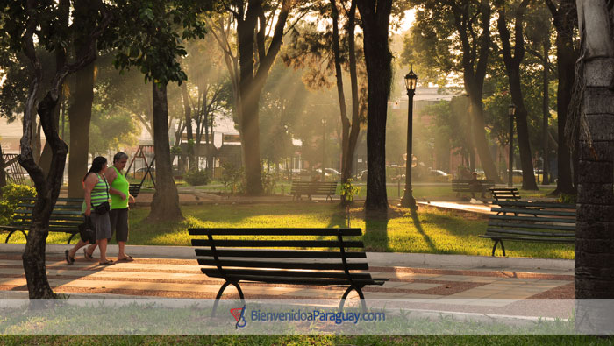

1. Livability criteria: 40.

Environment: 60; Health care: 50; Education: 30; Politics stability: 30; Safety: 30

1. There’s a lot to do in Asuncion, but most of all in Paraguay as well.

First of all, we are a country that is so far behind in all purposes that I will propose start from **education**, because is the base of all, if we don’t have education then we have nothing. At this time I can confirm that education is random, you make your own path, if you learn, you learn by yourself.

Next thing, safety, there’s a lot of stealing, killing, sometimes kidnapping, I think it’s time to get into security so we can feel in a different atmosphere.

Infraestructure: this city is lacking of different transport, streets, parks, hospitals, solutions. It’s all collapsed.

1. Name five places.

* Saint Petesburg, Florida.

This city I had the grace to explore this year, in the web page there’s no information about how is livability scored here. But I can say, starting from the people, they are all encouraged to support the local communities, they are all about green spaces, the city always has something special to do, all arts are involved. I can say that the architecture is taken care of, there’s a hotel that was built in the 1920s and it’s like new.

Transport. There are no issues with this, there are buses almost at every hour, the city is not that big so it’s easier to move in it.

* Tokyo
* Melbourne
* Zurich
* Rotterdam
* Environment
* Health care
* Education
* Politics stability
* Safety