JULIÁN DARÍO OTERO NIÑO
Bogotá, Colombia

Three examples of flows.
1. Vehicule flow
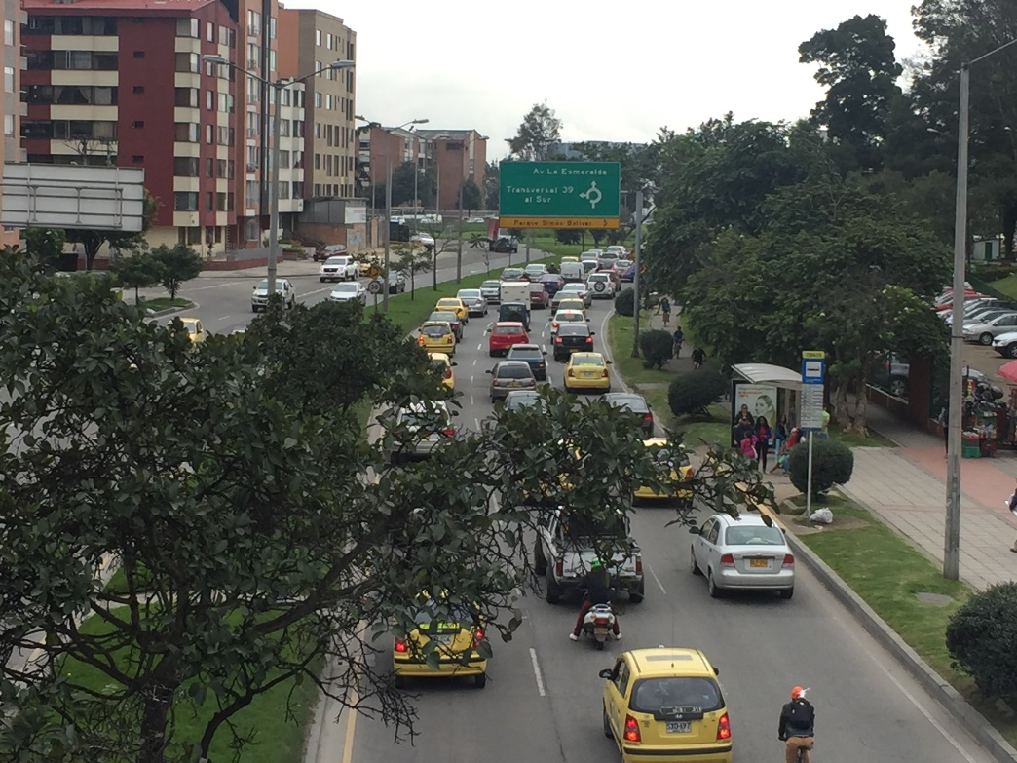
This is the 63th str. in Bogotá. There one can see the flow of people which is mentioned in the videos. The photo was taken from east to west, so it is possible to see a congested situation in the right road. In this case, there are a lot of people traveling home (a lot of travel production areas are in the western side of the city). In the future it seems to be more congested if there are no policies that regulate the transit of private vehicles or investments in the improvement of the public transport network.

2. Mobility apps
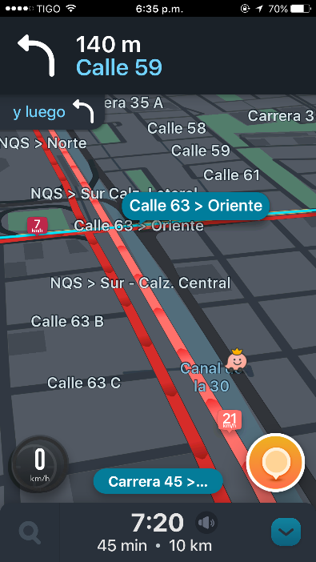
This is a screenshot of the application Waze in Bogotá. There we can see a flow of information. In the future, it can provide more accurate information about the congested travel routes.

3. Water supply and sewage treatment
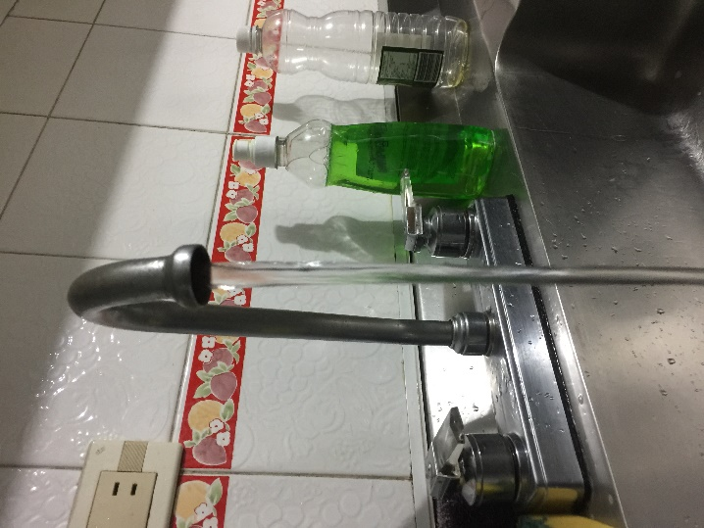
This is a photo of the water supply in a normal household. There one can see a flow of water, which was an important example in the first video (Irrawaddy river).

Three examples of stocks.
1. Water tank
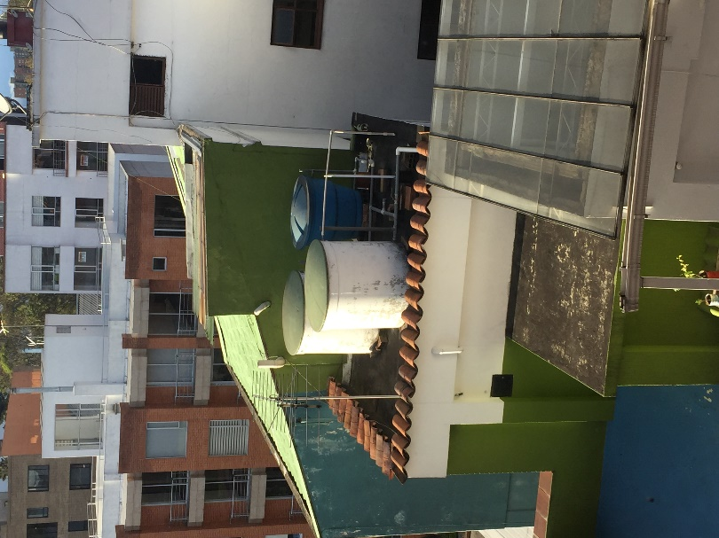
This the picture of some water tanks in a building that is located in a building beside the one where I live. It shows a stock of water. In the future, it seems to be no important change in this item. Perhaps different forms or materials for build the tanks, but the system itself is an efficient way to supply water to a high building.

2. Library
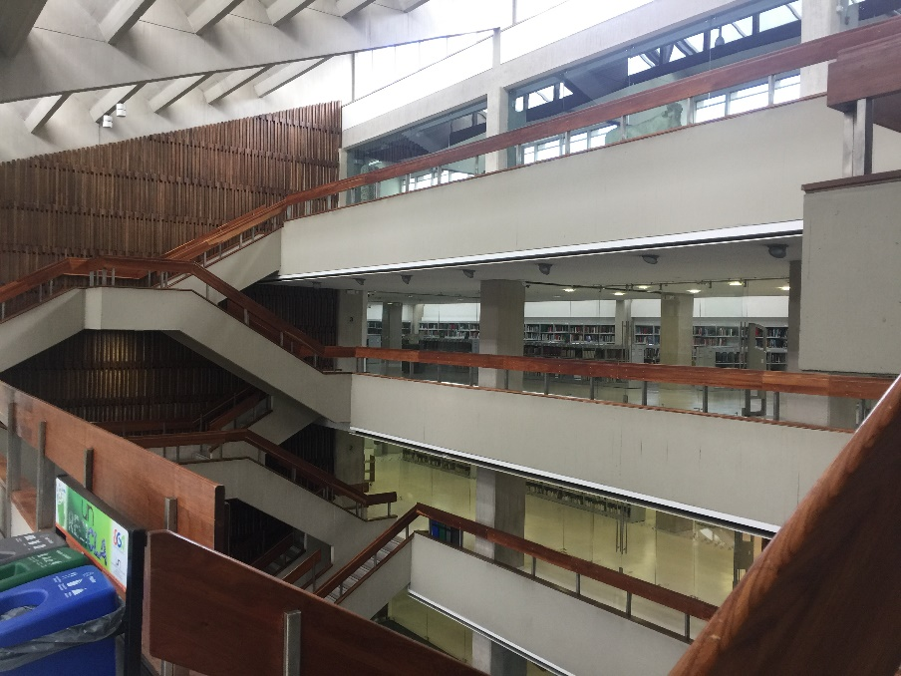
This photo was taken in the main library (library Gabriel García Márquez) of the National University of Colombia, where I actually make my undergraduate studies. This represents the stock of information. In the future, it can have no important changes because it is a very representative building in the university. Although, the collection of books can be changed to other libraries in the campus.

3. Concert Coliseum
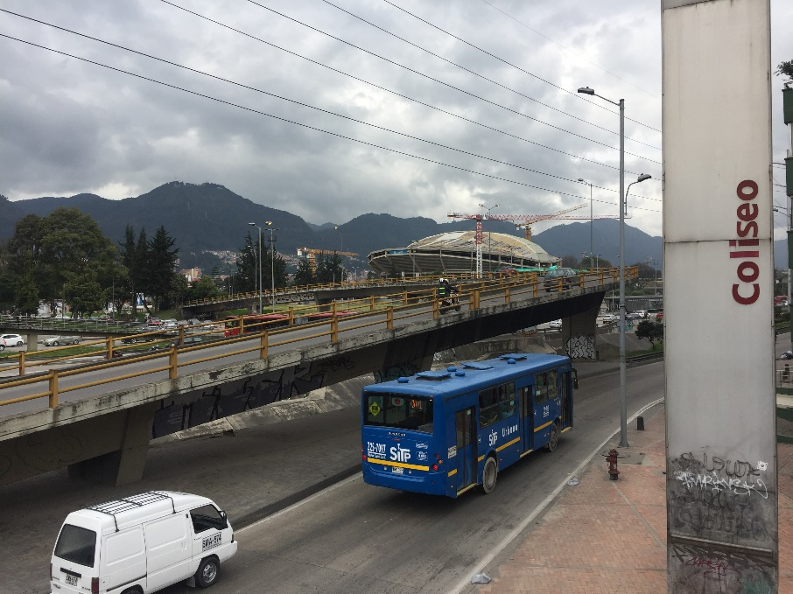
In this photo one can see the reconstruction of the concert coliseum of Bogotá. It shows a stock of materials.

